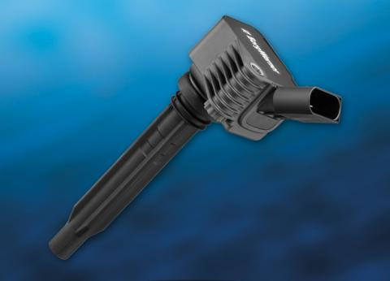

*Borgwarner’s high-energy plug top ignition coil with integrated electronics*

Borgwarner has produced plug top ignition coils with integrated electronics at its plant in Ramos-Arizpe, Mexico, for Volkswagen’s third generation 2.0- and 1.8-litre DOHC I4 engines built in Mexico. These engines power the Volkswagen Jetta and Beetle as well as other models designated for the US market.

Specifically designed for modern downsized engines, the compact plug top technology is said to deliver more ignition energy and higher voltage than conventional plug top or pencil ignition coils.

“Borgwarner’s plug top technology facilitates more complete combustion to enhance engine performance, improve fuel economy and reduce emissions,” said Brady Ericson, president and general manager for Borgwarner Emissions Systems. “We are pleased to provide Volkswagen’s modern gasoline engines with our advanced ignition technology. By offering localised production in North America as well as Europe and Asia, we can respond to our customer’s needs and react to changing market conditions quickly.”

The technology achieves an energy output of up to 100mJ. For engines that employ exhaust gas recirculation (EGR) to reduce emissions, this high-energy output enables EGR rates of up to 15 to 20 per cent without misfires. An integrated electronic IGBT communicates with the engine control unit to provide diagnostic data continuously, and an optimised magnetic circuit provides compact packaging to meet the tight installation specifications inside modern downsized engines.

Synthetic materials reduce weight, and a secure component connection technology inside the body of the ignition coil improves reliability and durability. In addition, the ignition technology’s modular construction provides rapid customisation and allows the energy output to be adjusted according to user specifications.